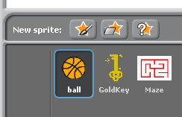
Create a Simple Maze Game
First of all we need to select a suitable round object to direct around the maze, Scratch has plenty of ball shaped objects in its own libraries.
Use this button to locate a round sprite, also locate a suitable target to aim towards, I chose a Gold Key, but anything will really do.

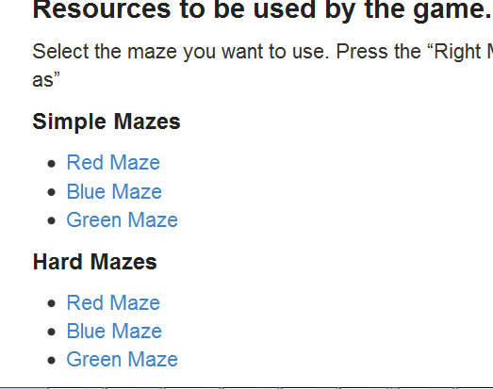
Save the Simple Mazes “Red” maze to your “my documents” ICT/Computing folder. Make a note of the folder that it gets downloaded into.

Now import the downloaded maze into Scratch by pressing this button. Navigate to the folder that you downloaded into to find the maze.

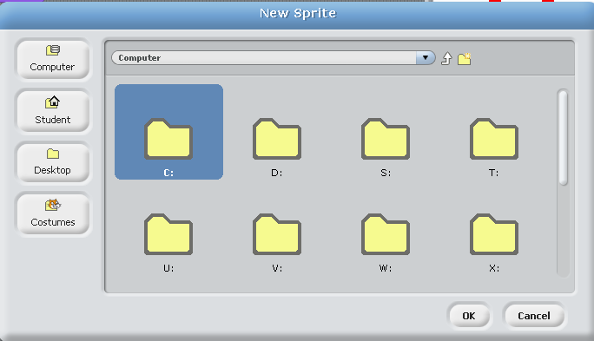
Press the “computer” button and then navigate to Your documents and load up the Red maze you recently downloaded.

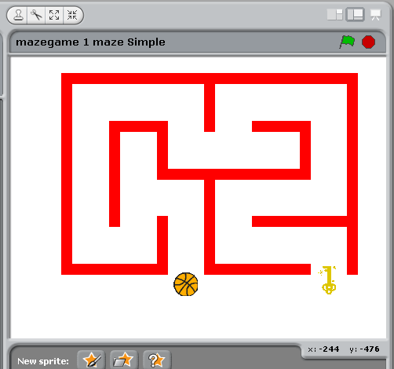
Next position the maze on the animation area
Next position the ball and Gold key at the start position and the finish position.
You will almost certainly have to resize the objects so use the increase and decrease size buttons to do this.
Place your mouse in the centre of the ball at its start position and make a note of its X and Y co-ordinates shown here.

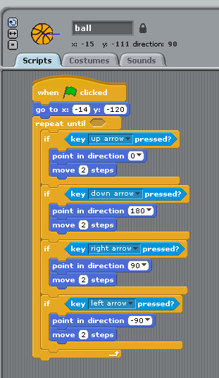
Here is the Script you need to control the ball sprite.
Note: take the opportunity to give the ball sprite a suitable name by changing it here

You will need to change the X and Y co-ordinates to the values you noted in the previous step.

By using the 4 direction arrows on the keypad you can control how the ball moves on the animation area.

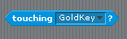
We need to put this in the hole at the right of the “repeat until” command (follow the green arrow above). This tells Scratch that we want to leave this loop when we touch the Gold Key
(i.e. we have finished the Maze)
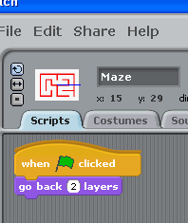
For the Maze Sprite we need to put this very small script for it.

This basically tells the Maze to be behind the ball and Gold Key.

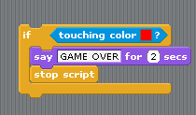
Now if you run this Script (By pressing the Green Flag) you will see that you can walk thru the walls of the maze. So what we need to do is basically end the running of the script if the ball touches the walls of the Maze. So we need to add the following code to the script.

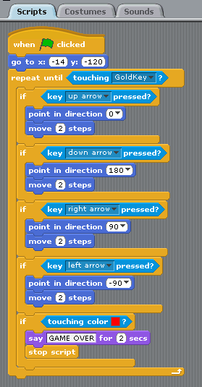
The Script should now look like this

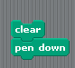
Additional Tasks
(You have to figure out exactly where these additional commands go)
Change the Script to leave a trail as it moves around the maze by using

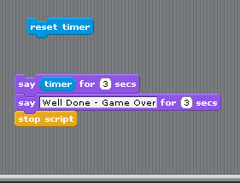
When the Ball touches the finish point (Gold Key in this case) output a suitable finish message which includes the total time taken to complete the maze

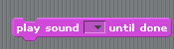
Add sounds when the ball hits the maze and when it finishes the Game

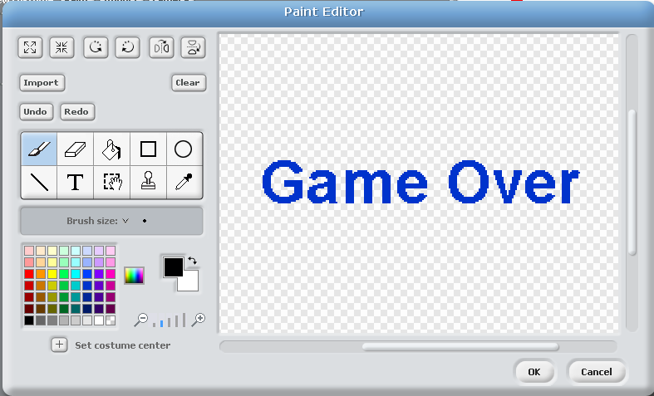
Add a “Game Over” message which appears in the centre of the Animation Area when the game is complete

